

**Faculty of engineering - Shoubra**

**Benha University**

**Research Article / Research Project / Literature Review**

in fulfillment of the requirements of

|  |  |
| --- | --- |
| **Department** | Engineering mathematics and physics |
| **Division** |  |
| **Academic Year** | 2019-2020 |
| **Course name** | Computer |
| **Course code** | ECE001 |

**Title: -**

**Artificial intelligence**

By:

|  |  |  |  |
| --- | --- | --- | --- |
|  | Name | Edu mail | B.N |
| 1 | مصطفي محمود جلال ذكي | mustafa196038@feng.bu.edu.eg | 932 |

|  |  |
| --- | --- |
| Examiners committee | Signature |
| Dr.Ahmed Bayoumi | 1 |
| Dr.Shady Elmashad | 2 |
| Dr.Abdelhamid Attaby | 3 |
|  |  |
|  |  |

**Githup link:** <https://github.com/mustafamahmou/html-project-repository>.

**Githup page:** [**https://mustafamahmou.github.io/html-project-repository/**](https://mustafamahmou.github.io/html-project-repository/)**.**

**Application brief:**

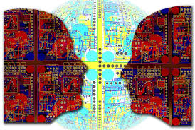AI or artificial intelligence is the simulation of human intelligence processes by machines, especially computer systems. This process includes learning, reasoning and self-correction. Some of the applications of AI include expert systems, speech recognition and machine vision. Artificial Intelligence is advancing dramatically. It is already transforming our world socially, economically and politically.

AI was coined by John McCarthy, an American computer scientist, in 1956 at The Dartmouth Conference where the discipline was born. Today, it is an umbrella term that encompasses everything from robotic process automation to actual robotics. AI can perform tasks such that identifying patterns in the data more efficiently than humans, enabling businesses to gain more insight out of their data. With the help from AI, large amounts of data can be analyzed to map poverty and climate change, automate agricultural practices and irrigation, individualize healthcare and learning, predict consumption patterns, and streamline energy-usage and waste-management.

**Applications of Artificial Intelligence:**

**Artificial Intelligence in Healthcare:** Companies are applying machine learning to make it better and very faster diagnoses than humans. One of the best known technologies is IBM’s Watson. It understands normal language and can respond to questions asked of it. The system mines patient data and other available data sources to form a hypothesis, which it then presents with a confidence scoring schema. AI is a study realized to emulate human intelligence into computer technology that can assist both, the doctor and the patients in a following ways:

AI can provide a laboratory for the examination, representation and cataloguing medical information

AI can devise novel tool to support decision making and research

AI can integrate activities in medical, software and cognitive sciences

AI offer a content rich discipline for the future scientific medical communities.

**Artificial Intelligence in business:** Robotic process automation is being applied for highly repetitive tasks normally performed by humans. Machine learning algorithms are being integrated into analytics and CRM (Customer relationship management) platforms to uncover information on how to better serve customers. Chatbots have already been incorporated into websites and e companies to provide immediate service to customers. Automation of job positions has also become a talking point among academics and IT consultancies.

**AI in education:** It automates grading, giving educators more time. It can assess students and adapt to their needs, helping them work at their own pace.

**AI for robotics**: will allow us to address the challenges in taking care of an aging population and allow much longer independence. It will drastically reduce, may be even bring down traffic accidents and deaths, as well as enable disaster response for dangerous situations for example the nuclear meltdown at the fukushima power plant.

**Screenshots:**

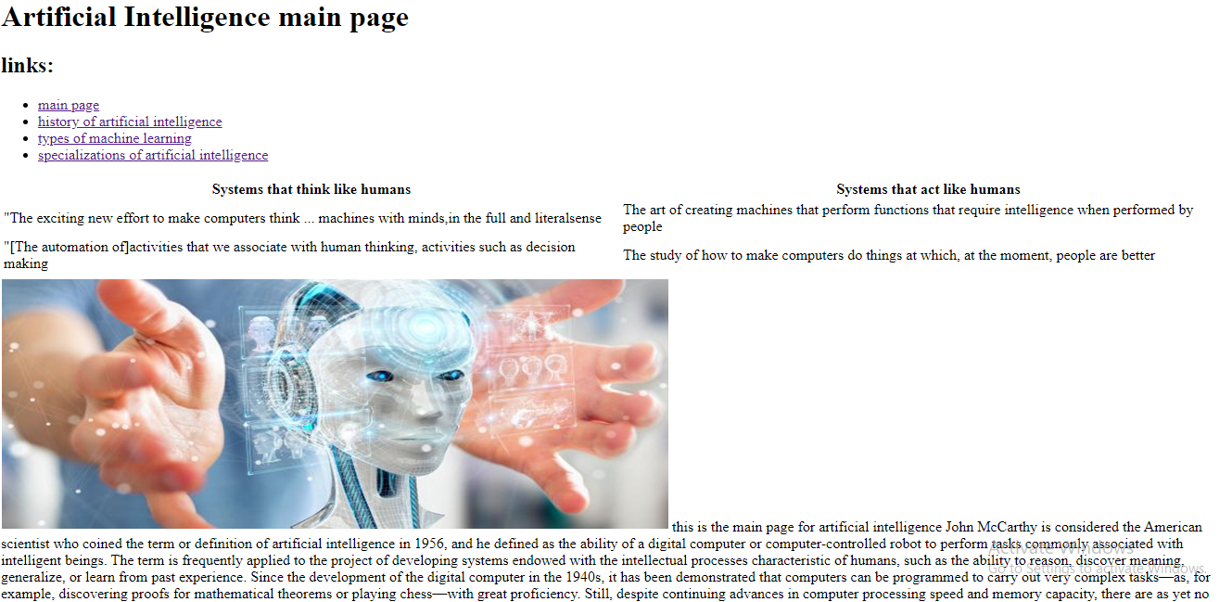

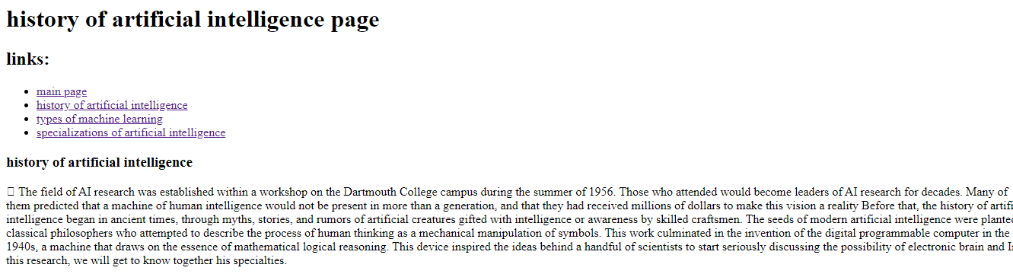

**Source code:**



